1. Using MR GREEN, list the 7 characteristics of living things.  
   M  
   R  
   G  
   R  
   E  
   E  
   N
2. Classify the following as living, non-living or dead.
   1. Steak:
   2. Mushroom:
   3. Metal chair:
   4. Paper:
   5. Sunflower oil:
3. What are the names of the 2 lenses in a microscope?
4. What is the function of a microscope’s stage?

**B**

1. 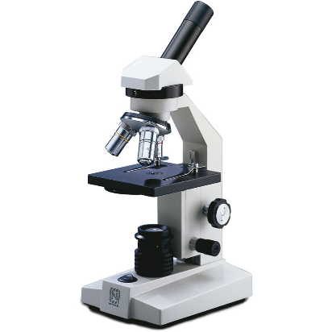Write the name of each part of the microscope.

**F**

**E**

**D**

**C**

**A**



1. After you have set up a microscope:
   1. What three things must you do before you look through the eyepiece lens?
   2. What two things must you do after you look through the eyepiece lens?
2. List 4 organelles found in both plant and animal cells.
3. Write the name of each organelle next to its function.  
   ________ produces proteins  
   ________ gets rid of waste  
   ________ allows transport through the cell  
   ________ releases energy from food
4. Write the name and function of one organelle found in plant cells but not animal cells.  
   Name:  
   Function:
5. In the space below, draw and label the three types of cells.

**Animal Cell Plant Cell Fungal Cell**

1. Can fungi make their own food? Why/why not?
2. Circle which types of cells have a cell wall.  
     
   animal plant fungi
3. State two differences between prokaryotic and eukaryotic cells.
4. Name 2 multicellular and 2 unicellular organisms.  
   Multicellular: 1. 2.   
   Unicellular: 1. 2.
5. Name a structure that would help a unicellular organism:  
   Move:   
   Detect light:   
   Engulf food:
6. Complete the table below about specialised human cells.

|  |  |  |  |
| --- | --- | --- | --- |
| **Name** | **Diagram** | **Adaptation** | **Function** |
| Red blood cell |  | Biconcave shape No nucleus |  |
| Fat cell |  |  | Insulating layer Stores energy |
| Nerve cell |  | Insulated, long |  |
| Muscle cell |  |  | Moves the bones of the skeleton, moves vital organs |
| Reproductive cell |  | Contains half the DNA of a normal cell  Flagellum (sperm) |  |